**LAND USE AND LAND-COVER CHANGE DETECTION AND ITS EFFECT ON BENGAL TIGER MORTALITY FOR CENTRAL INDIA.**

A Master’s Thesis

Presented to

The Graduate College of

Missouri State University

TEMPLATE

In Partial Fulfillment

Of the Requirements for the Degree

Master of Science, Geospatial Science

By

Tania Banerjee

August 2017

**LAND USE AND LAND-COVER CHANGE DETECTION AND ITS EFFECT ON BENGAL TIGER MORTALITY FOR CENTRAL INDIA.**

Department of Geography, Geology and Planning

Missouri State University, August 2017

Master of Science in Geospatial Science

Tania Banerjee

**ABSTRACT**

This research investigates land use/land cover change in central India and their impacts on tiger population. Central India situates in Deccan plateau with tropical climate patterns, including two large states: Maharashtra and Madhya Pradesh. Central India has the largest tiger reserves in India. The land cover of this area is dominated by forest, agricultural land, and urban settlement and so on. After the Green Revolution in the 1970s, the central India has undergone tremendous changes in land use/land cover. Time-series Landsat satellite imageries were processed and classified in a GIS environment to identify the land use/land cover changes. The relationships between tiger mortality and influential factors (e.g., urban settlement expansion, forest change and expanded agricultural land) are reveled with a repeated measure Poisson regression model. The results of the research will provide helpful informaiton for planning of tiger habitat convervation.

**KEYWORDS**: Land use and Land cover change (LULLC), Central India, Supervised Classification, Tiger mortality, Poisson regression.

This abstract is approved as to form and content

_______________________________

Dr. Jun Luo

Chairperson, Advisory Committee

Missouri State University

**LAND USE AND LAND-COVER CHANGE DETECTION AND ITS EFFECT ON BENGAL TIGER MORTALITY FOR CENTRAL INDIA.**

By

Tania Banerjee

A Master’s Thesis

Submitted to the Graduate College

Of Missouri State University

In Partial Fulfillment of the Requirements

For the Degree of Master of Science in Geospatial Science

August 2017

Approved:

_______________________________________

(Dr. Jun Luo)

_______________________________________

(Dr. Sean Maher)

_______________________________________

(Dr. Xin Miao)

_______________________________________

Julie Masterson, PhD: Dean, Graduate College

In the interest of academic freedom and the principle of free speech, approval of this thesis indicates the format is acceptable and meets the academic criteria for the discipline as determined by the faculty that constitute the thesis committee. The content and views expressed in this thesis are those of the student-scholar and are not endorsed by Missouri State University, its Graduate College, or its employees.

**ACKNOWLEDGEMENTS**

If desired, a page can be inserted for the purpose of acknowledging the assistance and support of others. A dedication can be included as well, but serves a separate purpose. If used, it should be clearly delineated. Single spacing is acceptable if necessary to keep this all on one page.

I would like to thank the following people for their support during the course of my graduate studies.

A dedication can be included as well. It should be separated from the rest of the acknowledgement. The following is an example.

I dedicate this thesis to (insert person to be dedicated here).

**TABLE OF CONTENTS**

Introduction 1

Literature Review 1

Animal Studies 4

Human Studies 8

Hypotheses 11

Methods 12

Experimental Design 12

Procedures 14

Statistics 17

Results 20

Experiment One 21

Experiment Two 30

Discussion 37

Data Limitations 40

Applications 46

Summary 55

References 62

Appendices 71

Appendix A. Human Subjects IRB Approval 71

Appendix B. Endocrine Data 72

**LIST OF TABLES**

Table 1. Graduate Enrollment at Missouri State University. 16

Table 2. Demographic analysis of thesis by department 23

Table 3. Number of theses with long-titled tables. Note that each table caption should be single-spaced if it is more than one line. 54

**LIST OF FIGURES**

Figure 1. Thesis questionnaire 17

Figure 2. Satisfaction scores 36

Figure 3. Number of theses with long-titled figures. Note that each figure caption should be single-spaced if it is more than one line 64

**INTRODUCTION**

**India is a country with a vast diversity of geography and culture. As a developing country, India has experienced rapid growth after independence in 1947. It is the second most populous country, and most of population live in rural areas. The rapid growth has caused considerable changes in the country. The Ministry of Environment and Forest has monitored many shifts in the climate, land use change, forest degradation and agriculture**

After independence of India in 1947, there was urgent demand to supply food to the fast-growing population. Green Revolution was initiated in 1950s. It was land-use and land-cover change (LULCC) detection showed that due to the Green Revolution, there was a significant decline of forest in India. These changes reflect the greatest environmental concerns of human populations today, including climate change, biodiversity loss and the pollution of water, soils, and air (E. Ellis, 2007The deforestation contributed to the decline in tiger population after the 1970s and since tiger was declared as the endangered species in 1970 by International Union for Conservation of Nature (IUCN). India has the largest tiger population in the world according to the census in 2016. The Wildlife Protection Act, 1972 is an Act of the Parliament of India enacted for protection of plants and animal species. Similarly, Project Tiger is a tiger conservation program launched in 1973 by the Government of India.

Of the original nine subspecies of tigers, three have become extinct in the last 80 years; an average of one every 20 years. It has been predicted all tigers may become extinct in the wild within the next decade (Tiger in Crisis, n.d.). Bengal tigers (Panthera tigris tigris) are the most numerous tiger subspecies with its remaining wild populations estimated at around 2,500 (Tiger in Crisis, n.d.). They are primarily found in parts of India, Nepal, Bhutan and Bangladesh. Bengal tigers are sometimes called Indian tigers and account for over half of all tigers remaining in the wild.

**Land-use and land-cover change** (**LULCC**) is a general term for the human modification of Earth's terrestrial surface (E.Ellis, 2007). Though humans have been modifying land to obtain food and other essentials for thousands of years, and intensities of LULCC are far greater than ever, driving unprecedented changes in ecosystems and environmental processes at local, regional, and global scales (E.Ellis, 2007). Natural scientists define land use in terms of syndromes of human activities such as agriculture, forestry and building construction that alter land surface processes including biogeochemistry, hydrology, and biodiversity (E. Ellis, 2007). Maps and measurements of land cover can be derived directly from remotely sensed data by a variety of analytical procedures, including statistical methods and visual interpretation. Maps of LULCC are produced from remotely sensed data by inferring land use from land cover. Application of remotely sensed data has made it possible to study the changes in LULCC in less time, at lower cost and with better accuracy if used in association with Geographical Information System (GIS) that provide a suitable platform for data analysis, update, and retrieval.

**1.2 Background**

Numerous studies have been done to investigate the changes of land use/cover and habitat shrinkage and fragmentation throughout the world (Wikramanayake et al., 1998), and their effects on wildlife. The technology of using satellite remote sensing, digital image processing, and GIS are widely used in these researches over years. Techniques like image fusion (Gharbia et al., 2014), supervised, and unsupervised classification yield better results for LULCC detection. Satellite-based remote sensing by its ability to provide synoptic information of land use and land cover at a particular time and location has revolutionized the study of land use and land cover (Roy and Roy, 2010).

**1.2.1 Land covers**

**1.2.1.1 Forest and Wildlife**

According to the widely-used United Nations Food and Agriculture Organization, forests covered an area of four billion hectares (15 million square miles) or approximately 30 percent of the world's land area in 2006. Forests play a significant role in the global carbon cycle as both carbon source and sinks, and have the potential to form a critical component in efforts to combat global climate change. Forests are not only a resource for human exploitation but also support wildlife. Only a small fraction of the forest that once covered the world remains. In India, deforestation is increasing greatly and the Protected Areas (PAs) are the cornerstone for the conservation of endangered species, but individual PAs may be too small to harbor a stable and resilient population of wide-ranging large carnivores (Dutta et al. 2015).

The tiger (*Panthera tigris*) is a flagship species that can help garner support for conservation across all sectors, and their conservation is a global priority (Dutta et.al, 2015). Tigers typify the challenges faced by many large carnivore species worldwide: small isolated populations in fragmented and shrinking habitat, illegal trade of their body parts, poaching, and conflict with humans. Like many other large carnivore species, breeding populations of tigers are confined to small PAs that are insufficient for their long-term survival (Dutta et.al.,2015). Continued habitat loss and fragmentation is one of the major causes for the decline. Many of the remaining habitat fragments are too small, isolated, or degraded to hold viable populations of tigers and their prey (Smith et al. 1999, Kinnaird et al. 2003, Lynam et al. 2006).

**1.2.1.2 Urban Settlement**

Urbanization is a population shift from rural to urban areas. It is an inevitable process due to economic development and rapid population growth. Urban growth, particularly the movement of residential and commercial land use to rural areas at the periphery of metropolitan areas, has been long considered a sign of regional economic vitality. Its benefits increasingly are compared against ecosystem impacts, including a decrease of air and water quality because of smoke from vehicles and factories, a decline of farmland and forests provide spaces for the vast population, socioeconomic effects of economic disparities because the rich becomes richer, and the poor becomes poorer, and facilities costs. Dryland degradation or desertification is also due to population growth which contribute to increased pressure on natural resources through overgrazing, over-cultivation, and over-harvesting of woodlands. These activities, in turn, lead to deforestation, soil erosion, and poor land management which result in further environmental degradation and desertification (Abdi et al., 2012). Remote sensing and GIS are effective means for extracting and processing various resolutions of spatial information for monitoring urban growth. Villages are at the boundaries of the PAs and occur throughout the landscape. Now as the shift of people to urban have increased, the cities have started expanding and including the villages in them. As a result, the PAs in the central part of India are now surrounded by big cities, several townships, urban centers and numerous villages These surrounding settlements are encroaching the PAs from all possible sides thereby causing shrinkage of the habitat. Therefore, wildlife in the forest can enter the cities and nearby habitation because they aren’t getting enough resources to survive and get killed and even the humans are entering the PAs for resources and killing wildlife either as poaching or for protection.

**1.2.1.3 Agriculture**

According to American Heritage Dictionary, agriculture can be defined as the science, art, and business of cultivating the soil, producing crops, and raising livestock. Agricultural intensification, defined as higher levels of inputs and increased output (in quantity or value) of cultivated or reared products per unit area and time, permitted the doubling of the world’s food production from 1961 to 1996 with only a 10 percent increase in arable land globally (Lambin et al., 2001). Agriculture has expanded into forests, savannas, and steppes in all parts of the world to meet the demand for food and fiber. Agricultural expansion has shifted between regions over time; this followed the general development of civilizations, economies, and increasing populations. Two recent studies estimated historical changes in permanent cropland at a global scale during the last 300 years by spatializing historical cropland inventory data based on a global land-cover classification derived from remote sensing, which used a hindcasting approach, or based on historical population density data. (Lambin et al., 2003)

The Green Revolution was an agricultural revolution in India in 1950s. During the period 1950–1991, areas of barren and uncultivable land, cultivable wasteland, land not available for cultivation and fallow lands showed a steady decline. There was greater use of such land for agricultural and non-agricultural uses. The area under permanent pasture and other grazing lands also decreased. The introduction of high-yielding varieties of crops additional irrigation facilities, and a high input flow through fertilizer and pesticides ushered in the Green Revolution in India. This radical change in land use raised India from a food importing country to a self-sufficient, as well as food-exporting, nation. It stimulated infrastructure and rural development, increased the prosperity of villages, and improved the quality of life. This transformation also showed side effects regarding regional imbalance, social inequality and the second-generation problem of soil degradation (Challa et al., 2004). Regional imbalance such as few states in India has more agricultural production, and few states still need to import from others. More and more forest was taken under cultivable land. This period showed a tremendous decrease in forest cover of the country leading to noticeable LULCC by the environmentalist. The government of India, therefore started paying more attention towards the concern.

**1.2.3 Effects of land cover changes**

Changes in land use and land cover date to prehistory and are the direct and indirect consequence of human actions to secure essential resources. This first may have occurred with the burning of areas to enhance the availability of wild game, and accelerated dramatically with the birth of agriculture, resulting in the extensive clearing and management of Earth’s terrestrial surface that continues today. More recently, industrialization has encouraged the concentration of human populations within urban areas, the depopulation of the countryside, and the intensification of agriculture in the most productive lands and the abandonment of marginal lands. All of these causes and their consequences are observable simultaneously around the world today (Ellis et al., 2013).

**1.2.3.1 Environmental Change**.

LULCC has negative impacts on the environment. The steady increase in global temperatures and accompanying climate changes in the past 150 years is simply an expression of natural variability, or they are a direct result of human activities. The most common problem that cities in central India faces is a continuous increase in temperature. Studies have shown that there is a striking difference in temperatures in urban and surrounding rural areas. (Katpatal et al., 2008).

Though LULCC certainly plays a indirectly role in greenhouse gas emissions, the complexity and dynamic interplay of land use processes favoring net accumulation versus net release of carbon dioxide and other greenhouse gasses makes it a poorly constrained component of our global budgets for these gasses, which is an active area of current research (E.Ellis, 2007). The ecological imbalance is another effect of LULCC. Biodiversity is often reduced dramatically by LULCC. When land is transformed from a primary forest to a farm, the loss of forest species within deforested areas is immediate and complete. Even when unaccompanied by distinct changes in land cover, similar effects are observed whenever relatively undisturbed areas are transformed to more intensive uses, including livestock grazing, selective tree harvest, and even fire prevention. The habitat suitability of forests and other ecosystems surrounding those under intensive use are also affected by the fragmenting of existing habitats into smaller pieces, which exposes forest edges to external influences and decreases core habitat areas. Smaller habitat areas support fewer species, and for species requiring an undisturbed core habitat, fragmentation can cause local and even global extinction.

**1.2.3.2Cultural Change**.

Human activity endangers tropical forests in different parts of the world (R. Weber et.al, 2007). The conflicting interests of nature conservation on the one hand, and the livelihood of farmers living at the woods margins on the other clash noticeably (R. Weber et.al, 2007). Cultural changes can be classified as a reduction of income from tourism and loss of cultural values and livelihood.

Tourism has always been a great source of income for people living near such areas. It has been supported because of the high proportion of revenue from this industry. Tourism depends on the land use and land cover. Tourists enjoy the natural beauty more. Therefore, the change in land cover sometimes causes the tourism of the areas to decrease. This reduction in travel can lead to loss of income from this industry.

Loss of cultural values and livelihood is a major issue caused by LULCC. From a socio-economic point of view, this means not only a loss of ecosystem services but also the decline of livelihoods and cultural values and a subsequent reduction of income from tourism (Brink and Eva, 2009). This is because the land cover changes the whole area sometimes to become barren which ultimately causes people to leave that place and immigrate to newer sites. Immigrating to new places causes the refugees to adapt to the existing pattern of the new area and thus lose their culture.

**2.1 Study area**

The landscape of central India is within the biogeographic zone of the Deccan plateau and is dominated by tropical dry deciduous and tropical moist deciduous forest (Champion and Seth 1968). The study areas are Kanha tiger reserve, Pench tiger reserve, Tadoba –Andheri Tiger Reserve, Bor Wildlife Reserve, Nagzira-Navegaon wildlife reserve, Melghat Wildlife Sanctuary, Umred wildlife sanctuary, Tipeshwar wildlife sanctuary, Achanakmar Wildlife Sanctuary, Narsinghgarh, Bandhavgarh and Panpatha Wildlife Sanctuary, Panna national park, Ratapani Tiger Reserve, Satpura national park, Nauradehi wildlife sanctuary, Sanjay- Dubri national park, Dewas range in central India. Figure 1 shows the study area in the India and tiger reserve. The area of interest (AOI) is marked in red and it covers most of the PAs. The figure 2 is the giving more details about the AOI and the location of the 19 forest patches. According to the Wildlife Protection Society of India in 1991, the elevation ranges from 284 m to 950 m above main sea level. The total area of the forest is divided into the core area and buffer area.

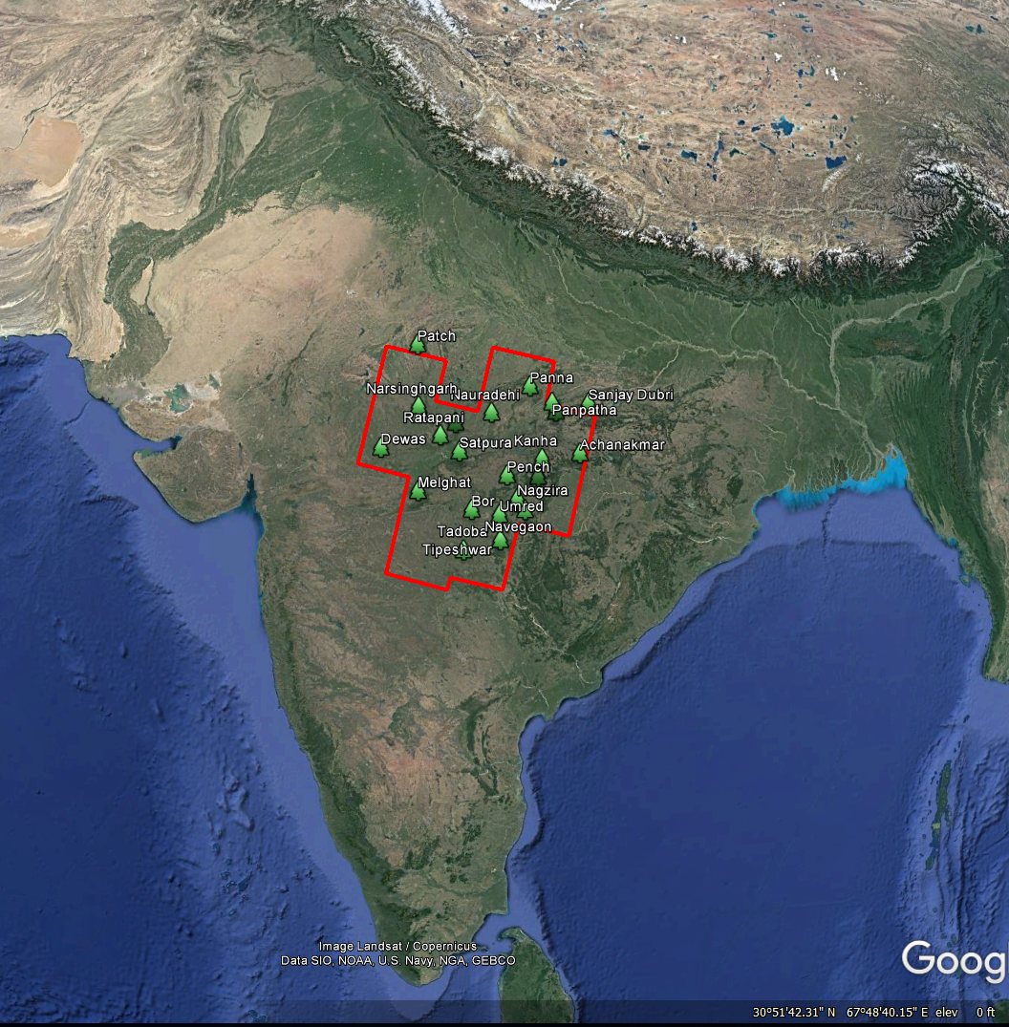

Fig. 1: Study area in central India and tiger reserves

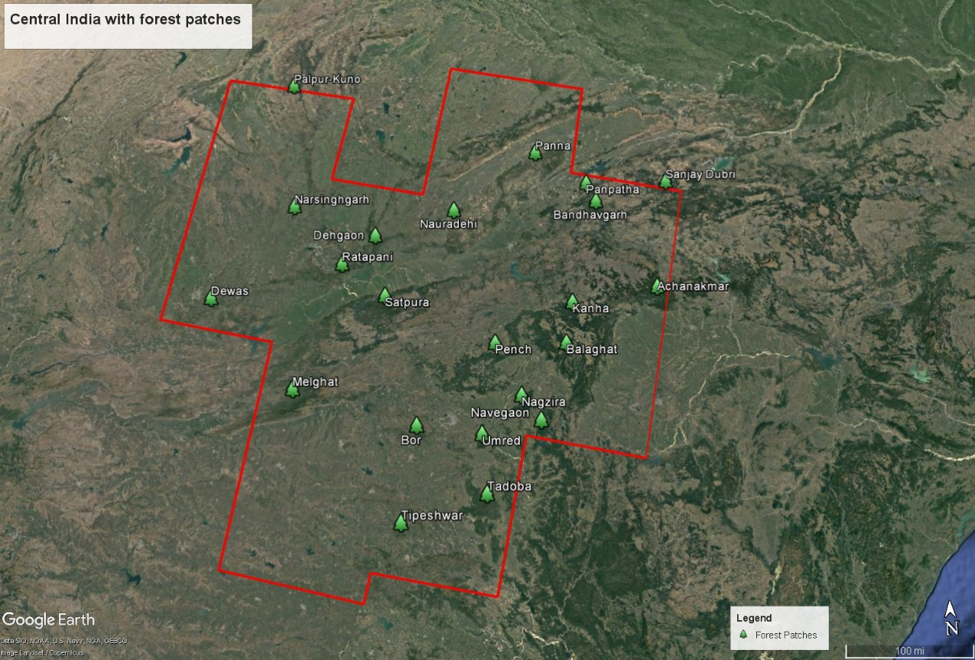

Fig 2: Central India with the forest patches Source:Google Earth Pro 7.1.5

The central Indian landscape supports about ~40% of the total tiger total population (Jhala et al. 2011). According to the tiger census report released on March 28, 2011, by the National Tiger Conservation Authority (NTCA), the tiger population estimation was 1,706, ranging from a minimum of 1,571 to a maximum of 1,875. The results include figures from 17 Indian states with a tiger existence. In 2008, the tiger population figure stood at 1,411 for entire India. The Tiger Census 2008 report had classified the forest for tiger habitat in India into 6 landscape complexes.They are (a) Shivalik-Gangetic Plains, (b) Central Indian Landscape Complex (c) the Eastern Ghats, (d) the Western Ghats, (e) North-Eastern Hills and Brahmaputra Plains, and (f) Sunder bans.

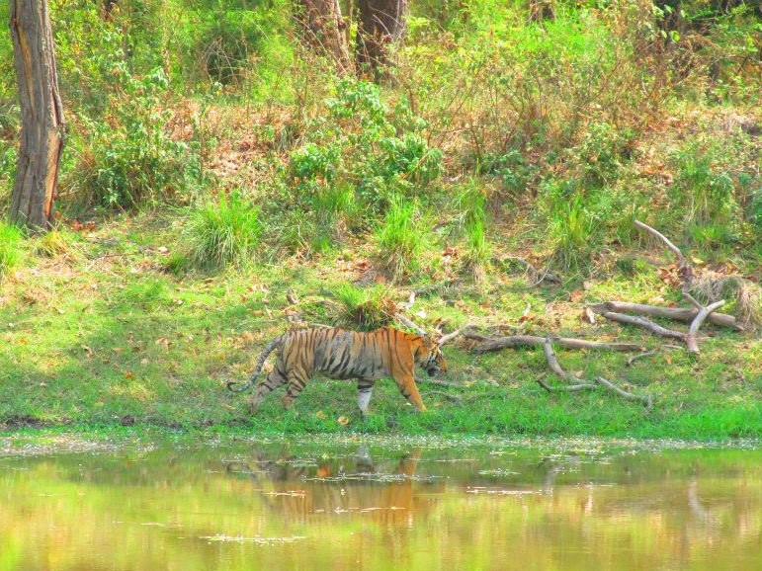

Fig 3: Kanha Tiger Reserve

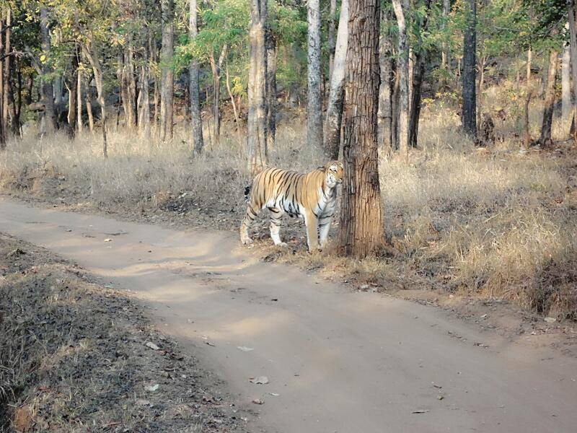

Fig 4a: Tadoba tiger Reserve

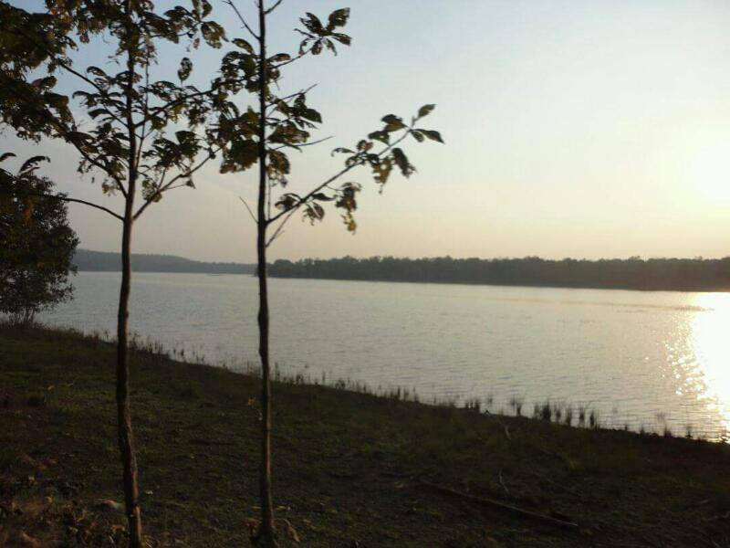

Fig 4b: Tadoba tiger reserve

Figure 3, figure 4a and figure 4b are images are taken from three major tiger reserves in year December 2015. Winters are the time when tigers are found in all the 19 patches and is the prime time for tourism.

**2.2 Image Used**

Landsat images were collected from between 2009 and 2016 to find out LULCC. The images of the year 2009, 2011, 2013, 2014 and 2016 were downloaded from United States Geological Survey (USGS) Earth Explorer website, and for 2010 and 2015, the images are taken from ArcGIS image server. Images of 2009 and 2011 were obtained from Landsat 5 Thematic Mapper (TM). As stated by an article of USGS Long Term Archive that very few images were acquired from November 2011 to May 2012 by Landsat 5 TM because the satellite began decommissioning activities in January 2013, and therefore, there were no images for 2012. Similarly, Landsat 7 Enhanced Thematic Mapper Plus (ETM+) images after 2003 had a scan line corrector problem and, therefore, 2012 images were distorted. Remaining images of 2013, 2014 and 2016 were obtained from Landsat 8 Operational Land Imager (OLI).

Eleven Landsat scenes were to cover the study area with the 19 forest patches for each year. To avoid the cloud cover and better visibility, the images captured in the month of October, November, December, and January were used. Landsat TM 5 images consist of seven spectral bands with a spatial resolution of 30 meters for bands 1 to 5 and 7. Band 6 (thermal infrared) has a resolution of 120 meters, but resampled to 30-meter pixels. Enhanced Thematic Mapper plus Landsat 7 which has eight bands with a spatial resolution of 30 meters for bands 1 to 7. The resolution for band 8 (panchromatic) is 15 meters. Landsat 8 Operational Land Imager (OLI) and Thermal Infrared Sensor (TIRS) consists of nine spectral bands with a spatial resolution of 30 meters for bands 1 to 7 and 9. Band 8 is 15 meter, and thermal bands 10 and 11 are useful for more accurate surface temperature and are collected at 100 meters.

**2.3 Methods**

**2.3.1 Data Processing**

The process of LULCC begins with data processing. First, images taken from USGS were of spatial reference WGS 1984 UTM Zone 43N and 44N and map units was in meters. There is a metadata file (MTL.txt) in the Landsat image package. Landsat Metadata files contain beneficial information for the systematic searching and archiving practices of data and explain the essential characteristics of the Level-1 data products. Metadata describe individual parameters used during processing of the data, including the processing levels of each scene. Values important for enhancing Landsat data (such as conversion to reflectance and radiance) also are included in this file.MTL.txt files were used to mosaic the eleven images for each year. Mosaic is a tool for merging multiple existing raster datasets into an existing raster dataset. To get the existing dataset, create raster dataset tool was used.

There were two images taken from ArcGIS server imagery. The spatial reference was WGS84 with map units in degree. These imageries also have the collection of Landsat images in them, but they cannot be clipped. The good thing about these images is that there is no need to mosaic. Because the study area is central India, a shapefile called area of interest (AOI) was made to define processing extent.

The next step was to create polygon feature classes for all the 19 forest patches. They were manually digitized in GIS environment. A buffer zone of 10 kilometers was created for each forest patch polygon to encompass the potential movements of tigers around habitat.

* + 1. **Supervised Image Classification**

In supervised classification reference classes are used as additional information. This process safely determines which classes are the result of the classification. The following steps are the most common:

* Definition of the land use and land cover classes.
* Classification of suitable training areas.
* Execution of the true classification with the help of a suitable classification algorithm.
* Verification, evaluation, and inspection of the results ("Classification-Introduction to Remote Sensing," n.d.).

The user selects representative samples for each land cover class in the digital image. These**sample land cover classes are called “training sites”.** In this research, for every land cover, seven or more samples were used. The area from which the sample is supposed to be taken is enlarged to get the correct landcover and polygons were drawn which served as a sample for the training set. The seven polygons of each landcover is merged into one class. The image classification software uses the training sites to identify the land cover classes in the entire image. Unlike the unsupervised classification method, sample sections of the known area with similar spectral reflectance were chosen as a signature set. These training sets were used to categories pixels of similar reflectance values into units that were labeled after areas of identifiable features, such as forest, urban, agricultural, water and so on. These samples are named accordingly as water, urban, forest, agriculture. In ArcGIS 10.4.1, there are two types of supervised classification methods. One is Interactive supervised classification, and other is Maximum likelihood classification.

In Maximum likelihood classification, the training samples are converted into a signature file (filename. gsg). The signatures generated from the training samples are then used to train the classifier to classify the spectral data into a thematic map (Lu and Weng, 2007). The interactive supervised classification is a quicker method. There is no requirement for the signature file; only training samples are created to obtain the result. In both the cases, the output is a raster file.

After the classification result is obtained, the tabulate area tool was used to calculate the area of those 19 patches with the buffer. This tool derived the area of all four land covers for each forest patch.

**2.3.3 Accuracy Assessment**

It is not easy to get the field data of all the 19 patches because of the vast area. Some are accessible easily, but some require permission to do research. Usually, acquiring permission includes a lot of government paperwork. Some areas have a local tribal government which make it harder to reach there. Therefore, accuracy assessment was used to find the user and producers accuracy. In the context of information extraction by image analysis, accuracy “measures the agreement between a standard assumed to be correct and a classified image of unknown quality” (Campbell, 2007). Accuracy assessment is performed by comparing the classification results by remote sensing analysis to a reference map based on a different information source ("Classification Accuracy Assessment” n.d.). In this case, the other source was Google Earth Pro 7.1.5. The Google Earth Pro 7.1.5 has the time slider option which gives the satellites of all the years. The accuracy of image classification is most often reported as a percentage correct. The user’s accuracy is computed using the number of correctly classified pixels to the total number of pixels assigned to a category. It takes errors of the commission into account by telling the user that, for all areas identified as group X, a certain percentage are correct. The producer’s accuracy informs the image analyst of the number of pixels correctly classified in a category as a percentage of the total number of pixels belonging to that category in the image. Producer’s accuracy measures errors of omission.

After that, the confusion matrix was created, and overall accuracy and Kappa values were evaluated. Below given is the formula to calculate Kappa coefficient (K; Equation 1),

$\frac{K=(N\sum_{i=1}^{r}{X_{ij}-\sum_{i=1}^{r}{(X_{i}*X_{j})}}}{N^{2}-\sum_{i=1}^{r}{(X_{i}*X_{j})}}$ Equation 1.

Where N is the total number of same point and X is the element in row i and column j.

**2.3.4 Statistical Analysis**

Land use database for the nineteen forest patches for seven years was constructed with the image classification results, as shown in Table 1. The area of water doesn’t have a direct effect on the tiger mortality. Therefore, it was not taken into consideration.

Table 1: Year-wise area of the land covers and count of tiger mortality

|  |  |  |  |  |  |
| --- | --- | --- | --- | --- | --- |
| **Patches** | **Forest** | **Urban** | **Agriculture** | **Tiger** | **Year** |
| Achanakmar | 2099.6715 | 52.2468 | 1226.3985 | 0 | 2009 |
| Panna | 644.8581 | 341.9199 | 3832.6563 | 0 | 2009 |
| Kanha and Pench | 17418.7798 | 723.0528 | 12028.3434 | 15 | 2009 |
| Tipeshwar | 33.6387 | 65.871 | 854.5851 | 0 | 2009 |
| Palpur_Kuno | 83.3138 | 430.452 | 505.8396 | 0 | 2009 |
| Panpatha and Bandhavgarh | 861.111 | 499.5594 | 1689.2172 | 4 | 2009 |
| Navegaon | 248.3712 | 92.8863 | 449.1279 | 0 | 2009 |
| Narsinghgarh | 163.4269 | 104.7798 | 446.706 | 0 | 2009 |
| Nagzira | 842.3176 | 123.9993 | 2181.6351 | 1 | 2009 |
| Dehgaon | 562.4974 | 727.6059 | 2170.7937 | 0 | 2009 |
| Satpura | 694.4508 | 508.2543 | 4053.8349 | 0 | 2009 |
| Melghat | 421.4403 | 136.7532 | 4060.2825 | 0 | 2009 |
| Umred | 122.0094 | 38.0574 | 644.3631 | 0 | 2009 |
| Tadoba | 2017.763 | 313.7148 | 3670.1451 | 10 | 2009 |
| Sanjay Dubri | 398.6874 | 16.3593 | 269.8398 | 0 | 2009 |
| Nauradehi | 20.643 | 37.4508 | 579.9213 | 0 | 2009 |
| Ratapani | 144.7112 | 88.3899 | 546.5682 | 1 | 2009 |
| Dewas | 577.6749 | 82.4715 | 1067.4153 | 0 | 2009 |
| Bor | 86.3919 | 16.2864 | 583.4682 | 0 | 2009 |
| Achanakmar | 1722.3147 | 23.1444 | 682.4142 | 1 | 2010 |
| Panna | 787.9077 | 284.8761 | 3277.4634 | 0 | 2010 |
| Kanha and Pench | 11588.2884 | 690.7572 | 9875.5299 | 9 | 2010 |
| Tipeshwar | 27.6534 | 36.4806 | 851.6646 | 0 | 2010 |
| Palpur_Kuno | 75.0627 | 44.8974 | 817.2711 | 0 | 2010 |
| Panpatha and Bandhavgarh | 607.6539 | 357.4593 | 1175.283 | 2 | 2010 |
| Navegaon | 90.0666 | 8.2278 | 154.9998 | 0 | 2010 |
| Narsinghgarh | 147.7512 | 7.2108 | 517.2831 | 0 | 2010 |
| Nagzira | 777.2418 | 103.8024 | 1747.4004 | 0 | 2010 |
| Dehgaon | 509.3244 | 35.955 | 2448.5796 | 0 | 2010 |
| Satpura | 2458.9908 | 160.3413 | 2583.8523 | 0 | 2010 |
| Melghat | 2033.9937 | 24.7761 | 1928.7171 | 1 | 2010 |
| Umred | 120.6189 | 15.0939 | 666.6984 | 0 | 2010 |
| Tadoba | 1939.2543 | 122.5872 | 2393.3646 | 5 | 2010 |
| Sanjay dubri | 0.000567 | 20.89452 | 290.862999 | 0 | 2010 |
| Nauradehi | 6.4206 | 69.6582 | 552.6252 | 0 | 2010 |
| Ratapani | 137.3733 | 13.6548 | 515.4984 | 0 | 2010 |
| Dewas | 858.2913 | 6.678 | 759.4272 | 0 | 2010 |
| Bor | 53.8956 | 2.6703 | 627.5439 | 0 | 2010 |
| Achanakmar | 1692.513 | 167.7132 | 600.0453 | 0 | 2011 |
| Panna | 1541.8548 | 492.21 | 2342.6739 | 0 | 2011 |
| Kanha and Pench | 13239.9279 | 1798.488 | 7137.0909 | 2 | 2011 |
| Tipeshwar | 55.9476 | 14.859 | 846.0036 | 1 | 2011 |
| Palpur_Kuno | 0 | 45.6093 | 709.2009 | 0 | 2011 |
| Panpatha and Bandhavgarh | 752.1282 | 193.9158 | 1222.4133 | 3 | 2011 |
| Navegaon | 100.4139 | 18.2088 | 137.3004 | 0 | 2011 |
| Narsinghgarh | 100.4139 | 18.2088 | 137.3004 | 0 | 2011 |
| Nagzira | 1353.5478 | 183.9141 | 1089.1584 | 0 | 2011 |
| Dehgaon | 28.8918 | 1336.518 | 1665.3069 | 0 | 2011 |
| Satpura | 995.3145 | 790.8219 | 3475.0503 | 1 | 2011 |
| Melghat | 1439.7741 | 1039.256 | 1506.6576 | 0 | 2011 |
| Umred | 373.1418 | 232.0821 | 178.6446 | 0 | 2011 |
| Tadoba | 942.1542 | 158.3424 | 3356.8173 | 6 | 2011 |
| Sanjay Dubri | 319.6719 | 28.4499 | 290.8629 | 0 | 2011 |
| Nauradehi | 99.0504 | 0 | 532.9575 | 1 | 2011 |
| Ratapani | 6.3585 | 339.6384 | 323.1171 | 0 | 2011 |
| Dewas | 0.1611 | 388.395 | 1225.5723 | 0 | 2011 |
| Bor | 477.0603 | 55.1187 | 137.8116 | 0 | 2011 |
| Achanakmar | 1561.8771 | 453.4776 | 437.0364 | 0 | 2013 |
| Panna | 1412.0397 | 258.8814 | 2709.8505 | 1 | 2013 |
| Kanha and Pench | 8013.2967 | 3798.331 | 10542.8439 | 3 | 2013 |
| Tipeshwar | 4.5432 | 138.8358 | 774.8046 | 0 | 2013 |
| Palpur_Kuno | 119.4462 | 364.2426 | 455.4576 | 0 | 2013 |
| Panpatha and Bandhavgarh | 1033.1316 | 293.0733 | 840.1113 | 6 | 2013 |
| Navegaon | 12.2994 | 8.1504 | 236.1276 | 0 | 2013 |
| Narsinghgarh | 79.4367 | 192.3552 | 403.0452 | 0 | 2013 |
| Nagzira | 15.6033 | 1409.482 | 1242.2394 | 0 | 2013 |
| Dehgaon | 709.4529 | 1423.166 | 876.177 | 0 | 2013 |
| Satpura | 2873.5281 | 1380.627 | 999.7263 | 0 | 2013 |
| Melghat | 2330.3754 | 1176.867 | 475.7724 | 4 | 2013 |
| Umred | 0.0288 | 633.8754 | 147.1104 | 0 | 2013 |
| Tadoba | 943.1496 | 539.3097 | 3012.8679 | 7 | 2013 |
| sanjay dubri | 465.5475 | 98.7381 | 112.221 | 0 | 2013 |
| Nauradehi | 88.3728 | 9.2187 | 533.727 | 0 | 2013 |
| Ratapani | 254.916 | 253.4751 | 158.6619 | 0 | 2013 |
| Dewas | 508.3893 | 237.6657 | 867.2904 | 0 | 2013 |
| Bor | 0.243 | 108.639 | 575.3466 | 0 | 2013 |
| Achanakmar | 1604.3526 | 425.6325 | 430.2207 | 0 | 2014 |
| Panna | 857.5929 | 391.833 | 3135.8925 | 1 | 2014 |
| Kanha and Pench | 3634.5707 | 2739.554 | 6067.0305 | 7 | 2014 |
| Tipeshwar | 43.7139 | 120.5316 | 757.7127 | 0 | 2014 |
| Palpur_Kuno | 57.5523 | 93.15 | 788.9742 | 0 | 2014 |
| Panpatha and Bandhavgarh | 841.4541 | 119.2725 | 1207.8261 | 7 | 2014 |
| Navegaon | 101.5686 | 4.7601 | 150.7518 | 0 | 2014 |
| Narsinghgarh | 0.3348 | 93.078 | 583.2702 | 0 | 2014 |
| Nagzira | 1004.0769 | 157.9923 | 1510.8849 | 0 | 2014 |
| Dehgaon | 629.0397 | 1586.78 | 794.8845 | 0 | 2014 |
| Satpura | 3062.799 | 923.67 | 1268.541 | 0 | 2014 |
| Melghat | 2230.3242 | 699.3999 | 1055.2572 | 1 | 2014 |
| Umred | 151.5672 | 74.4264 | 548.2836 | 2 | 2014 |
| Tadoba | 1859.9733 | 159.345 | 2489.1129 | 5 | 2014 |
| Sanjay dubri | 436.482 | 94.5027 | 152.8407 | 0 | 2014 |
| Nauradehi | 118.1061 | 239.8131 | 273.5604 | 0 | 2014 |
| Ratapani | 245.4957 | 196.4502 | 225.918 | 0 | 2014 |
| Dewas | 186.3108 | 461.115 | 967.5549 | 0 | 2014 |
| Bor | 157.5954 | 102.3093 | 428.4702 | 0 | 2014 |
| Achanakmar | 1534.4332 | 320.2722 | 802.1574 | 0 | 2015 |
| Panna | 1626.8328 | 767.1006 | 2860.4313 | 1 | 2015 |
| Kanha and Pench | 2220.0961 | 2568.812 | 7172.2143 | 5 | 2015 |
| Tipeshwar | 70.1037 | 93.33 | 880.7823 | 0 | 2015 |
| Palpur_Kuno | 28.5622 | 153.1701 | 768.2643 | 0 | 2015 |
| Panpatha and Bandhavgarh | 402.1775 | 230.2092 | 938.2365 | 3 | 2015 |
| Navegaon | 75.9401 | 26.4825 | 91.7244 | 0 | 2015 |
| Narsinghgarh | 12.3435 | 40.2291 | 752.5845 | 1 | 2015 |
| Nagzira | 1927.2924 | 221.022 | 922.4829 | 0 | 2015 |
| Dehgaon | 1155.1293 | 897.4854 | 1561.0131 | 0 | 2015 |
| Satpura | 2273.3361 | 1293.458 | 2684.9574 | 2 | 2015 |
| Melghat | 1390.7907 | 831.0411 | 2390.823 | 0 | 2015 |
| Umred | 270.0963 | 175.3911 | 472.9869 | 0 | 2015 |
| Tadoba | 1619.2224 | 425.2905 | 2179.3788 | 11 | 2015 |
| Sanjay dubri | 428.7892 | 55.6115 | 350.863597 | 1 | 2015 |
| Nauradehi | 255.3678 | 75.6342 | 420.111 | 0 | 2015 |
| Ratapani | 149.2425 | 247.7259 | 394.8993 | 1 | 2015 |
| Dewas | 437.7339 | 237.933 | 1223.3385 | 1 | 2015 |
| Bor | 97.6104 | 113.3271 | 575.7066 | 0 | 2015 |
| Achanakmar | 1426.3209 | 300.5163 | 740.3913 | 0 | 2016 |
| Panna | 1510.9011 | 1801.316 | 2439.7893 | 2 | 2016 |
| Kanha and Pench | 1520.3034 | 4380.592 | 7576.9155 | 24 | 2016 |
| Tipeshwar | 20.9133 | 77.094 | 826.4196 | 0 | 2016 |
| Palpur_Kuno | 92.1323 | 263.9556 | 666.6246 | 0 | 2016 |
| Panpatha and Bandhavgarh | 1035.9729 | 418.9041 | 714.699 | 7 | 2016 |
| Navegaon | 72.3033 | 66.7053 | 119.1996 | 0 | 2016 |
| Narsinghgarh | 10.3527 | 422.3574 | 208.3194 | 1 | 2016 |
| Nagzira | 1363.9463 | 431.9136 | 1509.7671 | 2 | 2016 |
| Dehgaon | 869.9445 | 600.8625 | 1545.7356 | 0 | 2016 |
| Satpura | 2112.7563 | 1880.068 | 1304.9154 | 0 | 2016 |
| Melghat | 1160.1825 | 1971.301 | 1462.6179 | 2 | 2016 |
| Umred | 154.6983 | 156.2193 | 475.7994 | 0 | 2016 |
| Tadoba | 1863.1179 | 588.8763 | 2072.2842 | 11 | 2016 |
| Sanjay Dubri | 422.8794 | 105.6114 | 149.1426 | 0 | 2016 |
| Nauradehi | 100.3527 | 422.3574 | 208.3194 | 0 | 2016 |
| Ratapani | 181.1781 | 135.0369 | 354.2175 | 0 | 2016 |
| Dewas | 290.8226 | 381.978 | 1144.1277 | 0 | 2016 |
| Bor | 54.6411 | 84.7656 | 586.5471 | 1 | 2016 |

The research attempts to reveal the LULCC factors contributing to tiger mortality. A regression analysis was performed with the tiger mortality as dependent variable and forest, urban and agriculture land uses as predictor variables. The patch and year are categorical variables. Below table 2 shows the different variables which will form the model,

Table 2: different types of variables.

|  |  |  |
| --- | --- | --- |
| Dependent variable | Independent variable | Categorical variable |
| Tiger Mortality | Forest area, Urban Area, Agricultural Area | Patch Name, Year |

To begin with the analysis, first, we need to standardize the mean as zero and variance as one for all the predictor variables. All the predictor variables were standardized to have a mean of zero and a variance of one. Poisson regression is an appropriate method to test for the relationship between a dependent variable measured in counts (i.e. tiger mortality) and a single or set of continuous variables. It’s best used for rare events, as these tend to follow a Poisson distribution, as opposed to more frequent events which tend to follow a normal distribution (Zeilieis et.al., 2016). Poisson regression analysis was then performed. Because there were 7 events per patch Poisson regression for repeated measure is used.

**3.1 Results**

**3.1.1 Classification results**

The supervised classification maps are built in ArcGIS 10.4.1 using the Landsat images and ArcGIS image server.

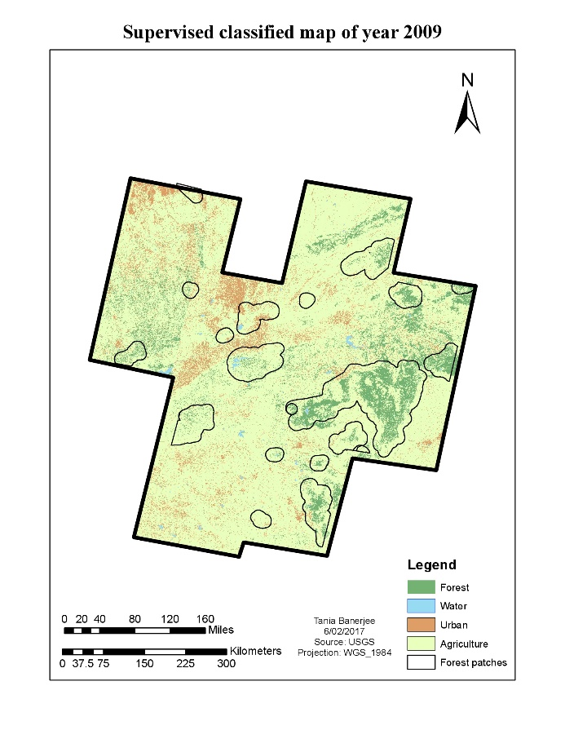

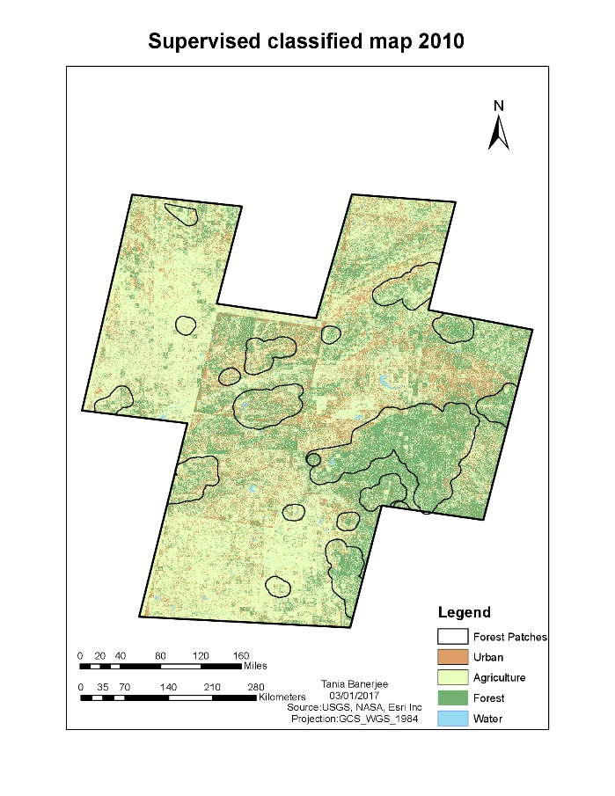

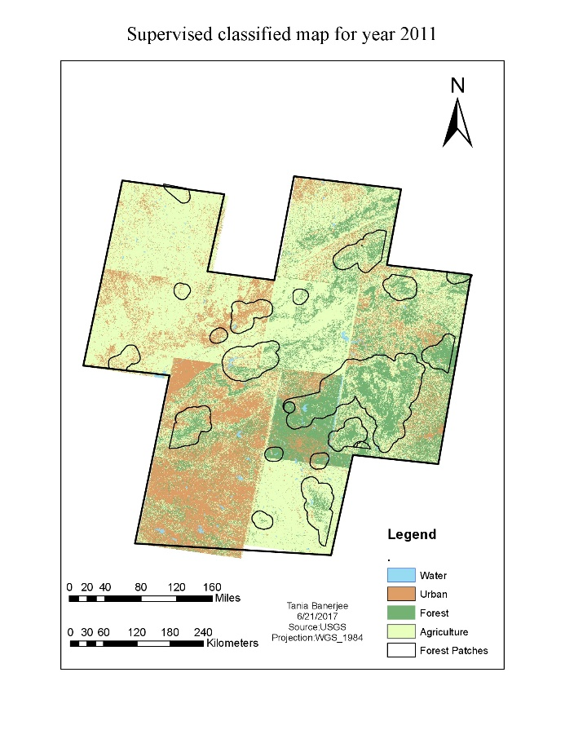

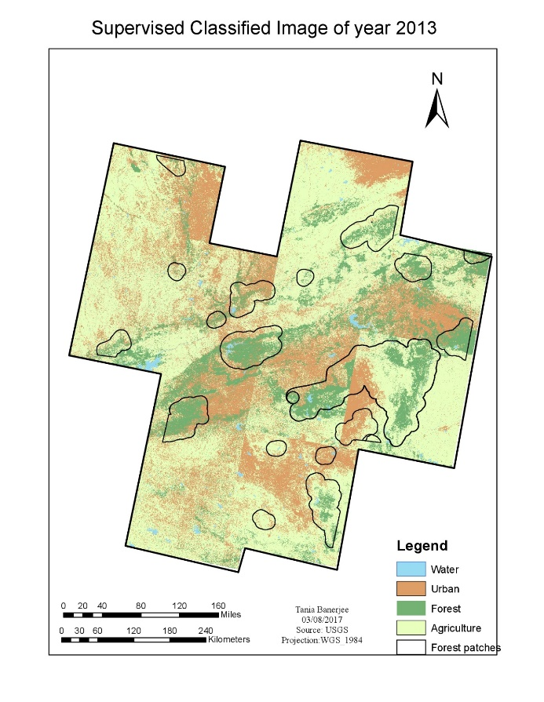

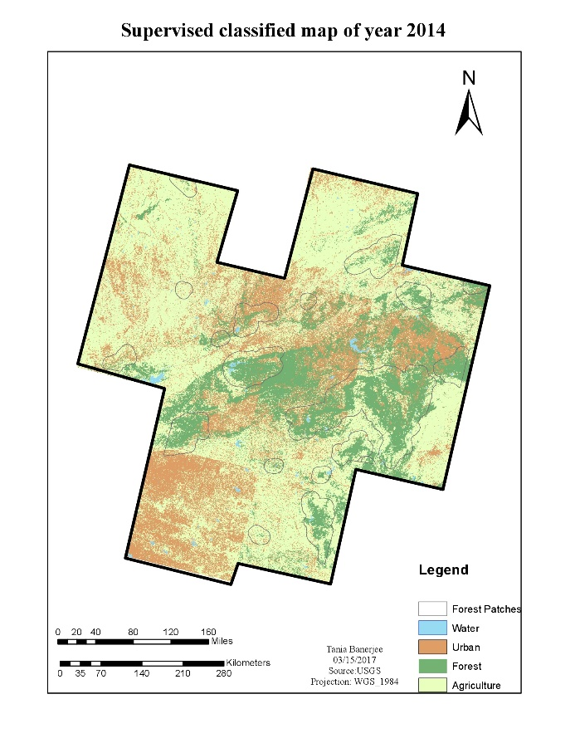

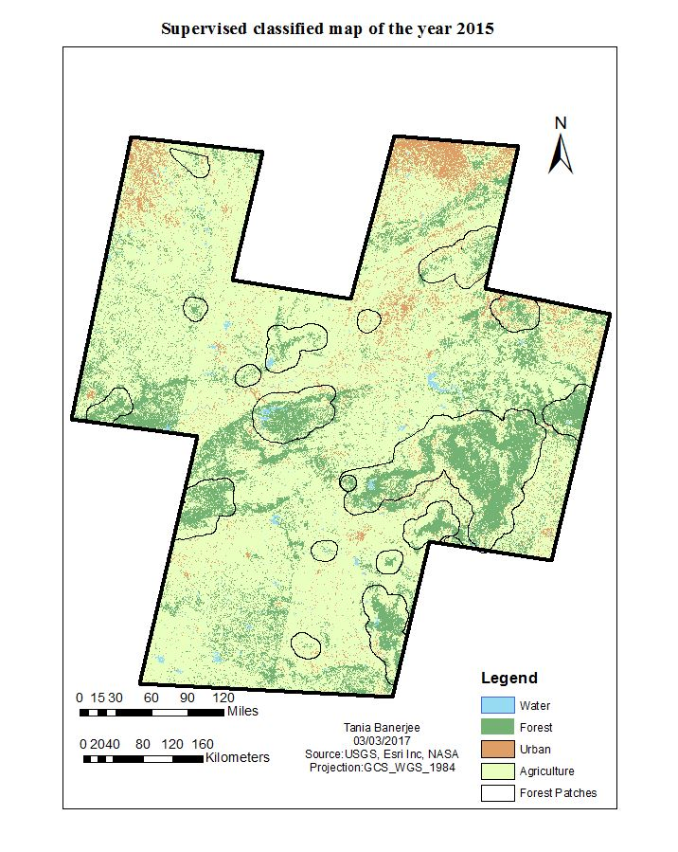

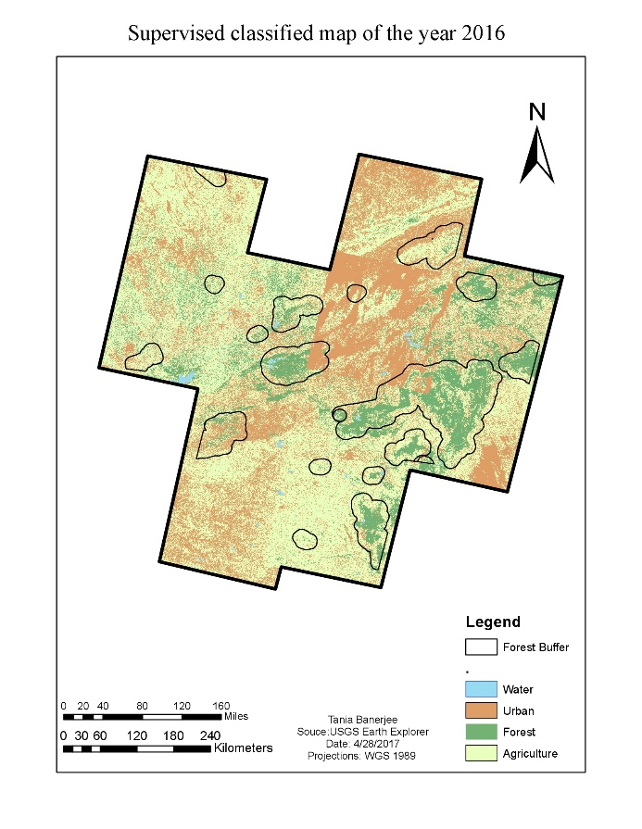

Figure 6: The classified maps of study area with the 19 patches from 2009-2016

Looking at the first two images of year 2009 and 2010, we find that forest area is not concentrated to the 19 patches instead it looks more scattered. This may be due to the pixel of agriculture and forest has fuzzy boundaries and the algorithm gets confused while classifying. India is an agricultural country and masses go for agriculture compared to the other job, therefore, agriculture is always on increase side. Due to the increasing population and limited land and resources for agriculture, forest land are turned into agricultural land and hence, deforestation keeps increasing.

Considering the image of year 2011, there are more urban pixels in the southern part of study area. This is because of the cloud cover. Out of the eleven images, only two images had cloud cover which is misclassified as urban. But the fact that urban is increasing cannot be denied. In table 2, the area of urban settlement can be observed from the visual interpretation of the classified images. Images of 2014, 2015 and 2016 have urban settlement spreading near the forest. Even water, in form of rivers or lake, apparently has declined over the years. Because central India is dry compared to the rest of India. Overall inferences are that there has been decrease in forest and increase in urban and agriculture from 2009 to 2016.

To find the shrinkage in terms of numerical data, the area of land cover is determined. The area of the land cover may also include an area which is not designated forest or PAs or might not be a proper farm but may be a fertile land with some wild trees and canopies or unused pasture.

Table 2: The area of the land covers are calculated

|  |  |  |  |  |
| --- | --- | --- | --- | --- |
| **Years** | **Urban** | **Agriculture** | **Water** | **Forest** |
| 2009 | 42345.6471 | 141128.5355 | 1659.555 | 70917.4999 |
| 2010 | 53639.7372 | 172489.1173 | 2759.1912 | 65956.4298 |
| 2011 | 71148.9582 | 196180.0121 | 3590.1837 | 63587.0000 |
| 2013 | 88626.141 | 204708.3284 | 3989.9664 | 62004.6018 |
| 2014 | 90907.4908 | 241754.0298 | 2912.9166 | 54437.7789 |
| 2015 | 96952.6097 | 275378.2224 | 3327.2514 | 52575.1227 |
| 2016 | 112393.7955 | 286930.2279 | 1415.0493 | 39352.9365 |

Figure 7: Graph is showing all the land cover regarding area (sq. km) vs. Years.

From the figure 7 above, overall similar results are observed as of the map classification. There is a steep increase in agriculture and a steady decline in the forest. As per Central Intelligence Agency (CIA), estimated agriculture land is 60.5% which includes 52.8% arable land, 4.2% permanent crops and 3.5% permanent pasture. According to the estimates in the year 2011, only 23.1% is under forest cover. In the data obtained, the agricultural area has increased from 141,128.53 km2 to 286,930.22 km2 in eight years whereas the forest has declined from 70,917.49 km2 to 39,352.93 km2

**3.1.2 Accuracy assessment results**

Table 3: Confusion matrix for the year 2009-2016.

|  |  |  |  |  |
| --- | --- | --- | --- | --- |
| **Classified** | **Reference** | | | |
| **Forest** | **Water** | **Urban** | **Agriculture** |
| **2009** |  |  |  |  |
| Forest | 34 | 0 | 0 | 6 |
| Water | 0 | 28 | 0 | 0 |
| Urban | 1 | 0 | 30 | 1 |
| Agriculture | 5 | 0 | 5 | 50 |
| **2010** |  |  |  |  |
| Forest | 26 | 0 | 2 | 24 |
| Water | 0 | 28 | 0 | 0 |
| Urban | 0 | 0 | 21 | 4 |
| Agriculture | 14 | 0 | 9 | 32 |
| **2011** |  |  |  |  |
| Forest | 29 | 0 | 0 | 16 |
| Water | 0 | 26 | 0 | 0 |
| Urban | 0 | 0 | 31 | 0 |
| Agriculture | 11 | 1 | 1 | 44 |
| **2013** |  |  |  |  |
| Forest | 36 | 0 | 0 | 6 |
| Water | 0 | 27 | 0 | 0 |
| Urban | 0 | 1 | 28 | 4 |
| Agriculture | 4 | 0 | 4 | 50 |
| **2014** |  |  |  |  |
| Forest | 32 | 0 | 0 | 5 |
| Water | 0 | 28 | 0 | 0 |
| Urban | 3 | 0 | 28 | 0 |
| Agriculture | 5 | 0 | 4 | 55 |
| **2015** |  |  |  |  |
| Forest | 35 | 0 | 0 | 6 |
| Water | 0 | 27 | 0 | 0 |
| Urban | 0 | 1 | 28 | 2 |
| Agriculture | 5 | 0 | 4 | 52 |
| **2016** |  |  |  |  |
| Forest | 37 | 0 | 0 | 9 |
| Water | 0 | 16 | 0 | 0 |
| Urban | 2 | 5 | 32 | 10 |
| Agriculture | 1 | 6 | 0 | 39 |

The accuracy assessment table 2, has the confusion matrix. The class accuracies are determined by test pixel with the corresponding locations in the classified image. It is not always possible to get the field reference and in such cases the user select references that they have visually identified from the imagery. Usually the process is to take test pixel evenly distributed through the image and they should be distinct from the training samples pixel used for supervised classifications. Confusion matrices are widely accepted method for determining accuracy assessment for classification. The rule is to have ten times the number of pixels for each class or land cover, so there are four landcovers. Therefore, 40 pixels for each landcover will give us total of 160 test pixels. But if any landcover is more than the other in that case more test pixels should be taken for the specific cover, and hence, the total remains same.

Table 4: The accuracy assessment for the classification of the years from 2009-2016.

|  |  |  |
| --- | --- | --- |
| **Classified** | **Producers accuracy (%)** | **User Accuracy (%)** |
| **2009** |  |  |
| Forest | 85 | 85 |
| Water | 100 | 100 |
| Urban | 84.375 | 84.375 |
| Agriculture | 83.33333333 | 83.33333333 |
| **Overall Accuracy 86.8%** |  |  |
| **Kappa Statistics 0.83** |  |  |
| **2010** |  |  |
| Forest | 65 | 50 |
| Water | 100 | 100 |
| Urban | 65.62 | 84 |
| Agriculture | 53.33 | 58.18 |
| **Overall Accuracy 66.8%** |  |  |
| **Kappa Statistics 0.64** |  |  |
| **2011** |  |  |
| Forest | 72.5 | 64.44 |
| Water | 92.85 | 100 |
| Urban | 96.87 | 100 |
| Agriculture | 73.33 | 77.19 |
| **Overall Accuracy 81%** |  |  |
| **Kappa Statistics 0.85** |  |  |
| **2013** |  |  |
| Forest | 90 | 85 |
| Water | 96.42857143 | 100 |
| Urban | 87.5 | 84.375 |
| Agriculture | 83.33333333 | 83.33333333 |
| **Overall Accuracy 88.1%** |  |  |
| **Kappa Statistics 0.85** |  |  |
| **2014** |  |  |
| Forest | 80 | 86.48648649 |
| Water | 100 | 100 |
| Urban | 87.5 | 90.32258065 |
| Agriculture | 91.66666667 | 85.9375 |
| **Overall Accuracy 89.3%** |  |  |
| **Kappa Statistics 0.86** |  |  |
| **2015** |  |  |
| Forest | 87.5 | 85.36 |
| Water | 96.42 | 100 |
| Urban | 87.5 | 90.32 |
| Agriculture | 86.66 | 85.24 |
| **Overall Accuracy 88.7%** |  |  |
| **Kappa Statistics 0.86** |  |  |
| **2016** |  |  |
| Forest | 92.5 | 80.43 |
| Water | 57.14 | 100 |
| Urban | 100 | 65.3 |
| Agriculture | 65 | 84.78 |
| **Overall Accuracy 77.5%** |  |  |
| **Kappa Statistics 0.74** |  |  |

Table 4 has producer accuracy, user accuracy, overall accuracy and Kappa statistics for each year. The overall accuracy value range 66.8% to 89.3%. In some cases, there has been confusion in the forest and agriculture signatures, and therefore, the accuracy of agriculture class is not as high as forest. Water has the highest accuracy of all because the signature file has been correctly classified. Even in most of the cases, urban class has been accurately classified.

In 2010, the overall accuracy value was less because of the forest and agriculture exhibit similar signatures due to fuzzy boundaries and mixing of adjacent pixels between them (Hamdan and Myint, 2014). It is visually clear that the agricultural cover has increased over the years and forest has decreased considerably. Therefore, the computerized classification result is accurate, and the change in land cover is verified.

**3.1.3 Poisson regression.**

To separately find the shrinkage in the designated forest by the government and the protected wildlife like tigers, the 19 forest patches were considered and the research was narrowed down to the core and buffer zones of the PAs. Table 5 has the result of the summation of the areas (sq. km) of all the 19 forest patches within the buffer zone. These all 19 patches are declared as the PAs by Government of India.

Table 5: Comparison of the total area of 19 forest patches over the years are shown below.

|  |  |  |  |  |
| --- | --- | --- | --- | --- |
| **Forest (Sq.Km)** | **Water (sq.km)** | **Urban (sq.km)** | **Agriculture (sq.km)** | **Year** |
| 27441.7579 | 386.67375 | 4400.1108 | 40861.1412 | 2009 |
| 23942.10387 | 1072.138823 | 2029.165316 | 31866.4792 | 2010 |
| 23518.3257 | 831.724457 | 7301.7495 | 26913.9852 | 2011 |
| 20425.6773 | 638.1117 | 12778.4106 | 25400.4174 | 2013 |
| 17222.9102 | 506.4012 | 8683.6158 | 22836.987 | 2014 |
| 15975.1001 | 483.2397 | 8773.5254 | 27442.9561 | 2015 |
| 14263.7196 | 299.1249 | 14490.4293 | 24105.8322 | 2016 |

Forest in these regions is shrinking with the increasing year. The deforested area is either covered with urban or with agriculture. A buffer was taken to evaluate whether the wildlife inside these PAs have enough space for movement or whether these areas are occupied by human settlement and agriculture. Since these PAs are also tiger reserves, then LULCC might have influence in increasing tiger death. Therefore, the tiger mortality data was obtained from National Tiger Conservation Authority (NTCA) official database to investigate further which land cover has a more significant effect.

The data for the independent variables need to standardize by making their means zero and variance one. Z-scores are also known as standardized scores; they are scores (or data values) that have been given a common standard. This standard is a mean of zero and a standard deviation of 1 (Van den Berg, 2016). The reason may be that many variables do follow normal distributions. Due to the central limit theorem, this holds especially for test statistics. If a normally distributed variable is standardized, it will follow a standard normal distribution (Van den Berg, 2016). Below is the table 6 with the standard values.

Table 6: The standardized values of all the independent variables

|  |  |  |  |  |
| --- | --- | --- | --- | --- |
| PatchName | Year | Forest | Urban | Agriculture |
| Achanakmar | 2009 | 0.455140105 | -0.563435446 | -0.137645264 |
| Panna | 2009 | -0.19018313 | -0.142003213 | 1.176135018 |
| Kanha and Pench | 2009 | 7.250359703 | 0.412489727 | 5.307473104 |
| Tipeshwar | 2009 | -0.461306616 | -0.543614216 | -0.32507151 |
| Palpur_kuno | 2009 | -0.439271834 | -0.013201883 | -0.50086953 |
| Panpatha and **B**andhavgarh | 2009 | -0.094258098 | 0.087339333 | 0.095655556 |
| Navegaon | 2009 | -0.366056001 | -0.504310883 | -0.529457152 |
| Narsinghgarh | 2009 | -0.403735424 | -0.487007571 | -0.530678 |
| Nagzira | 2009 | -0.102594437 | -0.459045993 | 0.343876943 |
| Dehgaon | 2009 | -0.226716525 | 0.419113825 | 0.338411936 |
| Satpura | 2009 | -0.168184899 | 0.099989148 | 1.287628241 |
| Melghat | 2009 | -0.289286353 | -0.440490924 | 1.290878392 |
| Umred | 2009 | -0.422107316 | -0.584078959 | -0.431041655 |
| Tadoba | 2009 | 0.418807296 | -0.183037532 | 1.094215259 |
| Sanjay Dubri | 2009 | -0.299379039 | -0.615646539 | -0.619833925 |
| Nauradehi | 2009 | -0.467071223 | -0.584961474 | -0.463525919 |
| Ratapani | 2009 | -0.412037297 | -0.510852492 | -0.480338778 |
| Dewas | 2009 | -0.21998412 | -0.519462903 | -0.217786605 |
| Bor | 2009 | -0.437906456 | -0.615752598 | -0.461737973 |
| Achanakmar | 2010 | 0.287752926 | -0.605775205 | -0.411860596 |
| Panna | 2010 | -0.126729473 | -0.224993646 | 0.896269578 |
| Kanha and Pench | 2010 | 4.664081922 | 0.365504326 | 4.22226813 |
| Tipeshwar | 2010 | -0.463961563 | -0.586372974 | -0.326543695 |
| Palpur_kuno | 2010 | -0.44293184 | -0.574127754 | -0.343881006 |
| Panpatha and Bandhavgarh | 2010 | -0.206686095 | -0.119395646 | -0.163411916 |
| Navegaon | 2010 | -0.43627644 | -0.627476689 | -0.677723259 |
| Narsinghgarh | 2010 | -0.41068882 | -0.628956276 | -0.495101012 |
| Nagzira | 2010 | -0.131460631 | -0.488429546 | 0.124984942 |
| Dehgaon | 2010 | -0.250302899 | -0.587137645 | 0.478440155 |
| Satpura | 2010 | 0.614526246 | -0.406173669 | 0.546629344 |
| Melghat | 2010 | 0.426006877 | -0.603401319 | 0.216384306 |
| Umred | 2010 | -0.422724112 | -0.617487512 | -0.419782724 |
| Tadoba | 2010 | 0.383982563 | -0.461100393 | 0.450607 |
| Sanjay Dubri | 2010 | -0.476227752 | -0.609048459 | -0.609236407 |
| Nauradehi | 2010 | -0.473379967 | -0.538104391 | -0.477285524 |
| Ratapani | 2010 | -0.415292228 | -0.619581193 | -0.496000656 |
| Dewas | 2010 | -0.095508855 | -0.629731422 | -0.373039356 |
| Bor | 2010 | -0.4523211 | -0.635562043 | -0.439519993 |
| Achanakmar | 2011 | 0.274533547 | -0.395448626 | -0.453381675 |
| Panna | 2011 | 0.207704883 | 0.076647025 | 0.425054485 |
| Kanha and Pench | 2011 | 5.396712887 | 1.977091539 | 2.841857043 |
| Tipeshwar | 2011 | -0.451410878 | -0.617829257 | -0.329397331 |
| Palpur_kuno | 2011 | -0.476228004 | -0.573092043 | -0.398357773 |
| Panpatha and Bandhavgarh | 2011 | -0.142600472 | -0.357327654 | -0.139654151 |
| Navegaon | 2011 | -0.431686605 | -0.612955785 | -0.686645294 |
| Narsinghgarh | 2011 | -0.431686605 | -0.612955785 | -0.686645294 |
| Nagzira | 2011 | 0.124176038 | -0.371878673 | -0.206826194 |
| Dehgaon | 2011 | -0.463412236 | 1.304992375 | 0.083602688 |
| Satpura | 2011 | -0.034728377 | 0.511083912 | 0.995870536 |
| Melghat | 2011 | 0.162424129 | 0.872519542 | 0.003629662 |
| Umred | 2011 | -0.310710506 | -0.301801238 | -0.665804226 |
| Tadoba | 2011 | -0.058309117 | -0.409081777 | 0.936270836 |
| Sanjay Dubri | 2011 | -0.334428578 | -0.598056474 | -0.609236457 |
| Nauradehi | 2011 | -0.432291424 | -0.639446941 | -0.487199753 |
| Ratapani | 2011 | -0.473407513 | -0.145322464 | -0.592977539 |
| Dewas | 2011 | -0.476156543 | -0.074388702 | -0.138061741 |
| Bor | 2011 | -0.264614544 | -0.559257249 | -0.686387605 |
| Achanakmar | 2013 | 0.216586335 | 0.020297016 | -0.535552318 |
| Panna | 2013 | 0.150121759 | -0.262812154 | 0.61014338 |
| Kanha and Pench | 2013 | 3.078294212 | 4.886572552 | 4.558652341 |
| Tipeshwar | 2013 | -0.47421274 | -0.437461044 | -0.365287811 |
| Palpur_kuno | 2013 | -0.423244296 | -0.109526931 | -0.526266433 |
| Panpatha and Bandhavgarh | 2013 | -0.017953543 | -0.213067912 | -0.332367562 |
| Navegaon | 2013 | -0.47077226 | -0.627589295 | -0.636827802 |
| Narsinghgarh | 2013 | -0.44099163 | -0.3595981 | -0.552686835 |
| Nagzira | 2013 | -0.469306723 | 1.411144238 | -0.129660075 |
| Dehgaon | 2013 | -0.161530297 | 1.431051886 | -0.314187317 |
| Satpura | 2013 | 0.798405877 | 1.369164555 | -0.251907739 |
| Melghat | 2013 | 0.557475283 | 1.072723388 | -0.51602601 |
| Umred | 2013 | -0.476215228 | 0.282749579 | -0.681700202 |
| Tadoba | 2013 | -0.057867579 | 0.145170239 | 0.762890466 |
| Sanjay Dubri | 2013 | -0.269721369 | -0.495797366 | -0.69928749 |
| Nauradehi | 2013 | -0.437027773 | -0.626035073 | -0.486811858 |
| Ratapani | 2013 | -0.363152871 | -0.270677534 | -0.675877243 |
| Dewas | 2013 | -0.250717689 | -0.293677912 | -0.318666935 |
| Bor | 2013 | -0.476120214 | -0.481392996 | -0.465831965 |
| Achanakmar | 2014 | 0.235427533 | -0.020213555 | -0.538988023 |
| Panna | 2014 | -0.09581865 | -0.069386912 | 0.824905549 |
| Kanha and Pench | 2014 | 1.13598764 | 3.346205852 | 2.302453668 |
| Tipeshwar | 2014 | -0.456837479 | -0.464090993 | -0.373903613 |
| Palpur_kuno | 2014 | -0.450699069 | -0.503927238 | -0.358145101 |
| Panpatha and Bandhavgarh | 2014 | -0.102977467 | -0.4659228 | -0.147007367 |
| Navegaon | 2014 | -0.431174406 | -0.632521688 | -0.67986462 |
| Narsinghgarh | 2014 | -0.476079494 | -0.504031988 | -0.461837783 |
| Nagzira | 2014 | -0.030841569 | -0.409591122 | 0.005760589 |
| Dehgaon | 2014 | -0.197199824 | 1.669087334 | -0.355165797 |
| Satpura | 2014 | 0.882362287 | 0.704358577 | -0.116401784 |
| Melghat | 2014 | 0.51309477 | 0.378078197 | -0.223915343 |
| Umred | 2014 | -0.408996126 | -0.531167353 | -0.479474068 |
| Tadoba | 2014 | 0.348815254 | -0.40762314 | 0.498872459 |
| Sanjay Dubri | 2014 | -0.282614186 | -0.501959257 | -0.678811633 |
| Nauradehi | 2014 | -0.423838735 | -0.290553758 | -0.61795842 |
| Ratapani | 2014 | -0.367331509 | -0.353640471 | -0.641974327 |
| Dewas | 2014 | -0.393584629 | 0.031408322 | -0.268124919 |
| Bor | 2014 | -0.406322149 | -0.490601789 | -0.539870427 |
| Achanakmar | 2015 | 0.204412824 | -0.173497468 | -0.351499624 |
| Panna | 2015 | 0.245399255 | 0.47657287 | 0.686049181 |
| Kanha and Pench | 2015 | 0.50855781 | 3.09780151 | 2.859562287 |
| Tipeshwar | 2015 | -0.445131544 | -0.503665365 | -0.311865846 |
| Palpur_kuno | 2015 | -0.46355844 | -0.416606722 | -0.36858469 |
| Panpatha and Bandhavgarh | 2015 | -0.297830908 | -0.304526035 | -0.282903939 |
| Navegaon | 2015 | -0.442542645 | -0.600918755 | -0.709619556 |
| Narsinghgarh | 2015 | -0.470752698 | -0.580919451 | -0.376488671 |
| Nagzira | 2015 | 0.378676527 | -0.317892075 | -0.290845122 |
| Dehgaon | 2015 | 0.036161954 | 0.666263792 | 0.031029555 |
| Satpura | 2015 | 0.532173903 | 1.24234561 | 0.597595096 |
| Melghat | 2015 | 0.14069617 | 0.569596998 | 0.449325813 |
| Umred | 2015 | -0.356419224 | -0.384278398 | -0.517430144 |
| Tadoba | 2015 | 0.242023449 | -0.020711115 | 0.342739572 |
| Sanjay Dubri | 2015 | -0.286026543 | -0.558540296 | -0.578990895 |
| Nauradehi | 2015 | -0.362952463 | -0.52941018 | -0.54408419 |
| Ratapani | 2015 | -0.410027312 | -0.279041784 | -0.556793076 |
| Dewas | 2015 | -0.282058871 | -0.29328903 | -0.13918777 |
| Bor | 2015 | -0.432930176 | -0.474572492 | -0.465650494 |
| Achanakmar | 2016 | 0.156456585 | -0.20223943 | -0.382635102 |
| Panna | 2016 | 0.193974502 | 1.981205577 | 0.474009081 |
| Kanha and Pench | 2016 | 0.198145156 | 5.733676754 | 3.06356684 |
| Tipeshwar | 2016 | -0.466951323 | -0.527286383 | -0.339269368 |
| Palpur_kuno | 2016 | -0.435360141 | -0.255429931 | -0.419819926 |
| Panpatha and Bandhavgarh | 2016 | -0.016693205 | -0.030002398 | -0.395586253 |
| Navegaon | 2016 | -0.444155849 | -0.542400431 | -0.695769669 |
| Narsinghgarh | 2016 | -0.471635773 | -0.024978349 | -0.65084555 |
| Nagzira | 2016 | 0.128788584 | -0.011075468 | 0.00519712 |
| Dehgaon | 2016 | -0.090339752 | 0.234720611 | 0.023328368 |
| Satpura | 2016 | 0.460944235 | 2.095777993 | -0.098065928 |
| Melghat | 2016 | 0.038403443 | 2.228508739 | -0.018570171 |
| Umred | 2016 | -0.407607239 | -0.412170579 | -0.5160124 |
| Tadoba | 2016 | 0.35021013 | 0.217282433 | 0.288754593 |
| Sanjay Dubri | 2016 | -0.288648 | -0.485797714 | -0.680675797 |
| Nauradehi | 2016 | -0.431713752 | -0.024978349 | -0.65084555 |
| Ratapani | 2016 | -0.395861382 | -0.442987891 | -0.577300236 |
| Dewas | 2016 | -0.347225493 | -0.083724504 | -0.179116893 |
| Bor | 2016 | -0.451990413 | -0.516125321 | -0.46018594 |

The tiger mortality data obtained is the count of the tigers died in that year. To find the mathematical model for establishing a relationship between tiger morality and land cover affecting it, Poisson regression was applied. Because each patch has a value for seven years, therefore, repeated measure Poisson regression was considered. Poisson regression is regular general linear model wherein the dependent (Y) variable is an observed count that follows the Poisson distribution. Thus, the possible values of Y are the nonnegative integers: 0, 1, 2, 3, and so on. It is assumed that large counts are rare. Hence, Poisson regression is like logistic regression, which also has a discrete response variable (“Poisson Regression”, n.d). Using R and R-Studio (You should provide citations), the combinations of all the independent variables on dependent variable were obtained.

Table 7: Statistical analysis table for the interactions of the independent variables.

|  |  |  |  |  |  |
| --- | --- | --- | --- | --- | --- |
| **Interactions of independent variables** | **Independent variable** | **Estimates** | **Standard error** | **Z value** | ***P*-value** |
| Forest2 + Urban2 + Ag2 + (1 | PatchName) + (1 | Year) | Forest | 0.00994 | 0.402 | -2.847 | 0.0044 |
| Urban | 0.11132 | 0.107 | 0.092 | 0.9266 |
| Agriculture | 0.355 | 0.117 | 0.945 | 0.344 |
| Intercept | -1.145 | 0.199 | 1.786 | 0.074 |
| Forest2+Ag2 +(1|PatchName)+(1|Year) | Forest | -0.06541 | 0.07297 | -2.797 | 0.0051 |
| Agriculture | 0.4114 | 0.19749 | -0.896 | 0.37 |
| Intercept | -1.16175 | 0.4152 | 2.083 | 0.0372 |
| Urban2+Ag2 +(1|PatchName)+(1|Year), | Urban | 0.1032 | 0.078 | 1.317 | 0.01907 |
| Agriculture | 0.367 | 0.1566 | 2.344 | 0.0044 |
| Intercept | -1.145 | 0.402 | -2.846 | 0.187 |
| Forest2+Urban2 +(1|PatchName)+(1|Year) | Forest | 0.125 | 0.08689 | 1.439 | 0.15 |
| Urban | 0.16791 | 0.11722 | 1.432 | 0.15203 |
| Intercept | -1.17129 | 0.42896 | -2.731 | 0.00632 |
| Forest2 +(1|PatchName)+(1|Year) | Forest | 0.0305 | 0.0558 | 0.548 | 0.583 |
| Intercept | -1.21 | 0.462 | -2.615 | 0.008 |
| Urban2 +(1|PatchName)+(1|Year) | Urban | 0.0365 | 0.077 | 0.47 | 0.638 |
| Intercept | -1.2 | 0.45869 | -2.617 | 0.0088 |
| Ag2 +(1|PatchName)+(1|Year) | Agriculture | 0.299 | 0.151 | 1.974 | 0.0484 |
| Intercept | -1.1737 | 0.425 | -2.759 | 0.0058 |

Above table 7, shows that there are in total seven models developed to test for significant effects.

The first model is the interaction between all the three variables together. All the models have the categorical variables such as ‘Patch name’ and ‘Year’ included with them in the interaction. The *P*-values from the table show that the agriculture is significant here. The next three model has the combination of only with two variables such as forest and urban, urban and agriculture, agriculture and forest. Similarly, even when only two variables are interacting, agriculture appeared to be significant. The last three models have only one variable predicting the categorical variables. In the model 5, model 6 the variable forest and urban are not at all significant whereas again model 7 has only variables as agriculture which is significant.

**4.0 Conclusion**

The Bengal tiger, also known as the Royal Bengal Tiger or the Indian tiger, is the subspecies with the largest population. It is the national animal of India, a place where its image is part of the traditions and the culture ("Bengal Tiger - Tiger Facts and Information," 2016). The main threats to this species are: poaching and conflicts with humans over the territories. Poaching’s aim is to illegally trade the products obtained from tigers, such as decorative objects or the active ingredient of “drugs” to cure various diseases, but which have no proven efficacy. Severely degraded by logging and invasion of humans in their territories, tiger habitat continues to decline. When tigers attack domestic animals or even humans, they unleash the wrath of people who in retaliation kill them ("Bengal Tiger - Tiger Facts and Information," 2016). But directly or indirectly they are related to the decreasing forest or increasing urban settlement and agriculture. Still the government or the forest official has not been able to find the reason of tiger mortality. Every year more and more tigers are dying and there is no urge to investigate the reason behind the death. Therefore, there is more scope for further research in this area.

LULCC has been a major area of research for many years. Many scholars and researchers have been working on the different land cover such as forests, agriculture, urban lands and so on. Growing population, widespread poverty, limited employment opportunities in agricultural and industrial sector has resulted in heavy pressure on forests, primarily due to unsustainable extraction of fuel wood and over-grazing resulting in forest degradation. Hence, there should be stringent law to protect them (Joshi and Singh, 2003). Agriculture is the most important occupation for most of the Indian families. In India, agriculture contributes about sixteen percent (16%) of total GDP and ten percent (10%) of total exports. Over 60% of India’s land area is arable making it the second largest country in terms of total arable land.

Using different classification techniques like fusion, band ratio, principle component analysis, supervised and unsupervised classification, the detection of land cover change has become easier. In India, land cover changes have significance because of the decline of the forests and their conversion into agriculture. Deforestation is one of the major causes to the environmental degradation which is affected by the agents like small farmers, ranches, loggers and plantation companies (Mondal, n.d.).  Along with this, many wildlife species are also endangered such as tigers. Since it is an alarming situation, the Government of India has started making policies for forest and tiger preservation.

This study focuses on two sections. First, the LULCC over the years from 2009-2016 of forest, water, urban and agriculture of central India. Secondly, the effect of land change on the tiger’s mortality. The classification result shows that there has been decrease in forest and increase in urban and agriculture. According to the results, the area of agriculture land is double in 2016 as compared to 2009. The accuracy of the land cover classifications in this research is quite high. The research was narrowed down to the 19 forest patches which concentrate on the tiger reserves and PAs. The observations from the repeated measure Poisson regression indicate that agriculture is an important land cover type that has effect on tiger mortality. If agriculture continues to increase, then forest shrinkage will increase leading to confinement to the movement of tigers. As a result, these big cats will interfere with the human habitation, destroying agricultural land and finally leading to death.

This research of LULCC has many limitations and constraints. The images obtained were having some percent of cloud cover. All the images are taken from the winter months of India but still they had some or few percent of cloud or haze. This caused some of the clouds to be classified in urban or water. Secondly, if high resolution images were obtained, the classification result would have been more accurate. For determining the forest patches used in the research there were no shapefiles available online. Therefore, these shapefiles were made by digitizing the borders of the forest. If these limitations were removed then the result would have been more accurate.

One of the objective of this study is to give suggestions to policy makers and environmentalists. Due to deforestation, the forest cover of India has fallen below the minimum recommended level. According to experts, forests should cover about one-third of the total area of country. But in India forests covers around 24% of the total area (Mehta, 2016). There are an estimated 300 million people living as shifting cultivators who practice slash and burn agriculture and are supposed to clear more than 5,000,000 ha of forests for shifting cultivation annually (Mondal, n.d.). There has been many non-governmental organization working in this field but none of them have got any support from the government. There have been laws made once in every five years but Government pays attention to them. There should be an education or awareness program for the tribes, forest dwellers and urban cities or township near the forest boundaries. They should be educated on how forests and their resources are inseparable from their life, how eco-cycle works and if deforestation continues then what they will face in the future. The boundaries of the forests should be protected strictly. There should be more security in the buffer zones so that there should be no provision for encroachment and trespassing, illegal settlement and habitation. Among those 19 forest patches, few are located quite close and therefore, tigers use existing forest corridors to move from one patch to another. But urban settlement and agriculture expansion has started destroying them too. The principle of sustainable development must be recognized and emphasis on Environmental Impact Assessment is needed. Because India is a developing country, it concentrates on the socio-economic development but it must be in coordination with environmental upgradation. Though the Environmental (Protection) Act is very ambitious and maintained different components of the environment in India, environment protection has been dominated more by socio-economic constraints and the priority of development. Therefore, sometimes with several compromises, the objective lost which has resulted in the failure of legislative mission.

The existing legal provisions are inadequate to control the enormous problems of environmental pollution of various types in the country. Therefore, the judiciary has to play a more active and constructive role. Environmental law should be implemented effectively by adopting new instruments, mechanisms and procedures like environmental impact assessment and environmental audit and incorporate environmental objectives in manufacturing processes, minimum usage of hazardous materials and toxic chemicals, careful usage of toxic gases will reduce environmental load.